Power Grid Risk Analyzer

Alicia Peters and William Lawther

CMPSC 463

Professor Janghoon

Project Description
Our project, PowerGridRiskAnalyzer, focuses on modeling how extreme wind conditions can affect the stability of an electrical power grid. Power grids can be represented as graphs, where each node is a power tower or station and each edge is a transmission line. When wind intensifies, these lines are at risk of failing. Our goal was to build a tool that simulates how severe wind might damage parts of a grid and then recommends which nodes should be reinforced to reduce risk. The project combines graph algorithms, probability-based simulation, and a user-friendly web interface, allowing anyone to input a wind value and instantly see how the grid behaves under that scenario. It showcases how the algorithmic concepts we learned in class can be applied to real-world, weather-related problems.

Significance of the Project
Weather-related grid failures are becoming more common, especially during storms and hurricanes. When transmission lines fail, entire communities can lose power, leading to dangerous conditions. Our project is significant because it demonstrates how algorithmic thinking can support better planning and prevention. Instead of treating outages as random events, we used structured graph analysis to estimate risk and identify the most vulnerable points in the grid. This gives users a clearer understanding of how reinforcement decisions impact overall grid stability. The project is also meaningful academically because it shows how techniques like greedy selection and MST analysis, which we normally study in abstract form, can be integrated into a practical, interactive system.

Code Structure
The code for PowerGridRiskAnalyzer is organized into a clean, modular structure to keep the logic easy to understand. The main web application is built in FastAPI, which handles routes and user inputs. The simulation logic lives inside separate Python files divided by purpose: graph construction, failure probability modeling, and algorithmic reinforcement selection. For example, simulate.py handles the full sequence from receiving inputs to calculating failure outcomes while the greedy and MST strategies are kept in their own modules. This separation allows every part of the project to be edited or improved independently. The repository also includes templates for the web interface, static files, and test cases, all stored in their respective folders.
PowerGridRiskAnalyzer/
├── Templates/ → HTML templates (front-end pages)
│
├── data/ → Sample grid data / test graphs
│
├── scripts/ → Helper scripts for running or setup
│
├── src/ → Core backend and algorithm code
│ ├── main.py → FastAPI web interface
│ ├── simulate.py → Simulation controller
│ ├── graph_utils.py → Graph building + risk calculation
│ ├── greedy.py → Greedy reinforcement algorithm
│ └── mst_method.py → MST-based reinforcement
│
├── static/js/ → JavaScript files for UI behavior
│
├── tests/ → Unit tests for simulation + algorithms
│
├── .github/workflows/ → GitHub automation (NOT part of project logic)
│
├── .venv/ → Virtual environment (ignore)
│
├── README.md → Project overview + instructions
│
└── requirements.txt → Python dependency list

Algorithms Used
We implemented two main algorithms for grid reinforcement: a greedy selection method and an MST-based method. The greedy algorithm repeatedly picks the node that provides the largest reduction in expected failures. At each step, it evaluates every remaining node, calculates how much risk would drop if that node were reinforced, and then selects the one with the highest impact. This approach aims to maximize benefits using local decisions.
The MST-based strategy works differently. It first generates a Minimum Spanning Tree of the grid to identify the backbone of the networkthe connections that hold everything together. Then it recommends reinforcing nodes that sit on or near the most essential edges in that tree. This method is less aggressive than greedy selection but helps protect critical structural paths in the system. Together, these algorithms allow for two styles of decision-making: targeted optimization and structural protection.

Verification of Algorithms
To verify that the algorithms behave correctly, we used small toy graphs where outcomes can be predicted by hand. For example, in a simple four-node path graph (0–1–2–3), the greedy algorithm naturally picked node 1 first because reinforcing it reduces risk on both adjacent edges at once. The MST method, on the other hand, identified the central edges as most important and recommended reinforcing nodes connected to them. These simple cases helped confirm that both approaches work the way they should before being used on larger, more complex graphs.
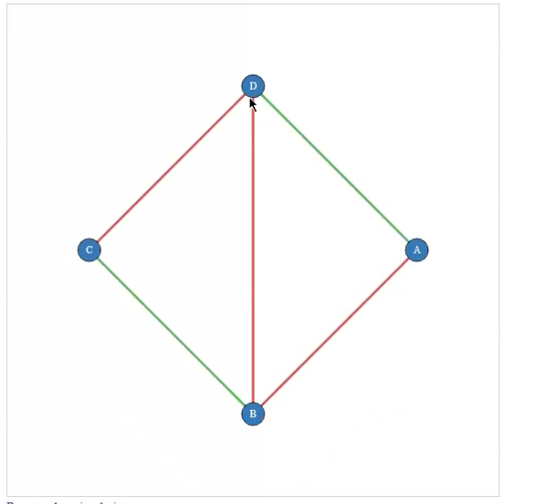
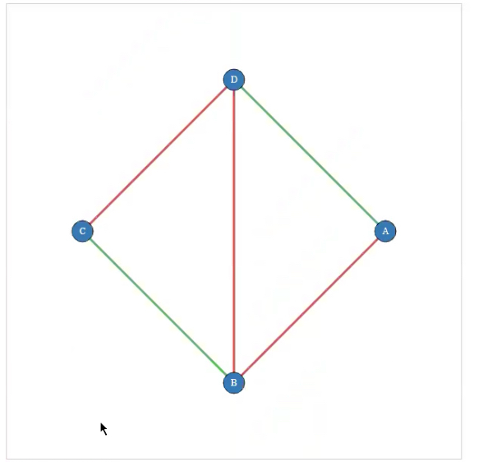

Functionalities
The web application includes everything a user needs to explore grid behavior under extreme wind. Users can enter a wind strength, choose between greedy, MST, or no reinforcement, and run a full simulation instantly. The program then calculates which transmission lines are likely to fail and how reinforcement changes the outcome. Results are displayed clearly so users can understand the level of risk and the benefit of reinforcement. Behind the scenes, the system computes failure probabilities, runs node selection, and compiles a summary of the grid’s stability.

Execution Results and Analysis
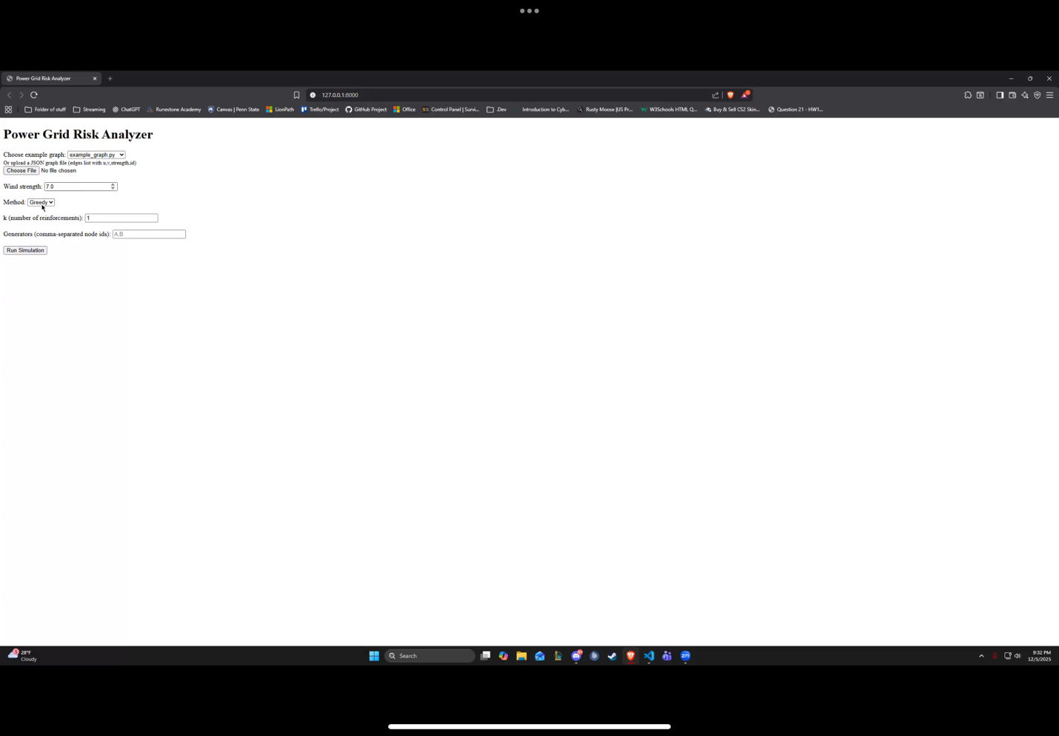
When we ran the simulation on example graphs, we noticed several consistent patterns. As wind speed increases, the expected number of failed lines rises sharply, showing how sensitive the grid is to severe weather. Reinforcing even one or two nodes led to meaningful improvements, especially when using the greedy method. In many cases, the greedy strategy provided the biggest reduction in failures because it focuses directly on maximizing impact. The MST method performed well when the grid had clear bottleneck edges or when protecting the structural backbone was more beneficial than local optimizations. Overall, the results show that algorithmic reinforcement strategies can significantly reduce weather-related risk.
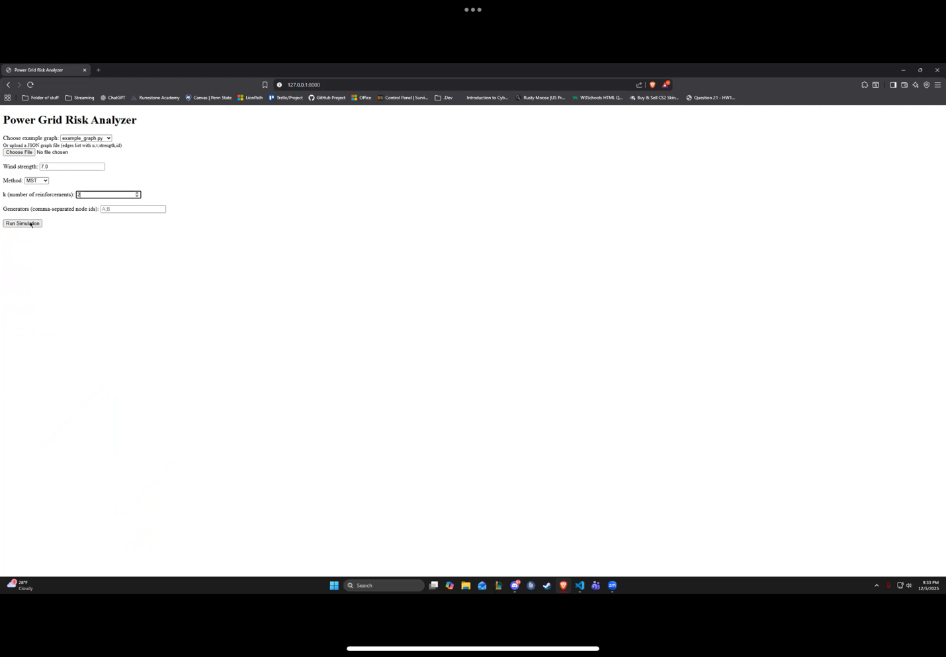
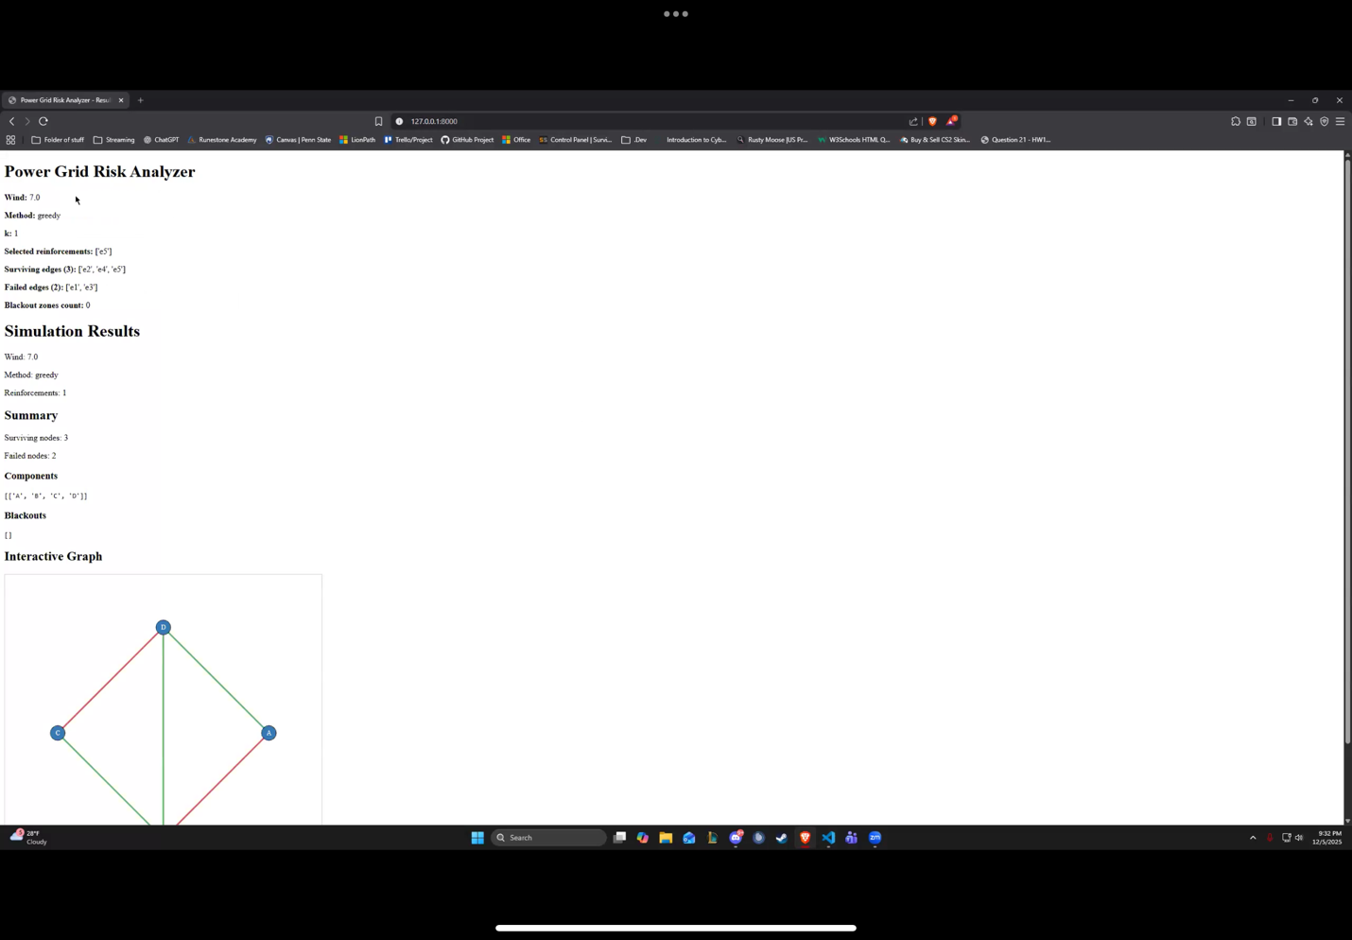

Conclusion
This project allowed us to take graph algorithms and apply them to a realistic and relevant challenge: protecting a power grid from extreme wind. We learned how to model grids, simulate weather damage, and compare reinforcement methods. Our findings show that even simple algorithms can make a noticeable difference in improving resilience. Although the system is simplified, the project demonstrates how algorithmic reasoning can support real-world decision-making. In future work, we could expand the grid models, incorporate more weather factors, or add visual network diagrams. Overall, PowerGridRiskAnalyzer was a valuable experience that connected classroom theory with practical problem-solving.

